# **Example of using metaphors**

Here's an example of how you can use metaphors in your storytelling.

﻿﻿  
﻿﻿  
﻿﻿

<iframe src="https://www.linkedin.com/embed/feed/update/urn:li:ugcPost:6830850501861535744" height="1000" width="500" frameborder="0" allowfullscreen="" title="Embedded post"></iframe>

Note that the similarities between data and walnuts aren't that clear.  
﻿﻿

But this little story reached 130k people. It shows the power of metaphors. It's not about finding a brilliant similarity between two things. Most important is that you're able to paint a picture in the head of the audience.  
﻿﻿

Can you spot the storytelling techniques I used?

﻿﻿

## **How to find metaphors for your Data presentation**

## **﻿﻿**

**﻿﻿Follow these 3 steps:**

1. Ask yourself: what's the point you're trying to make?
2. Write down all your associations.
3. Now, choose an association that your can relate to

﻿﻿

**Example:**

1. Soft skills are important for all Data professionals. However, they're often neglected.
2. What else is important, but often neglected? Hmm, healthy foods? Not really. Exercise? No, it's emphasized often. However, some people like working out their upper body, and not their legs!
3. Not everyone will be able to relate, but at least people that have been going to the gym. And it's easy to make the metaphor visual.

Et voilà!  
 ﻿﻿



﻿﻿  
﻿﻿

If you want to explain technical concepts, be a little creative:

﻿﻿



﻿﻿

## **Normal distribution in real life:**

## **﻿﻿**

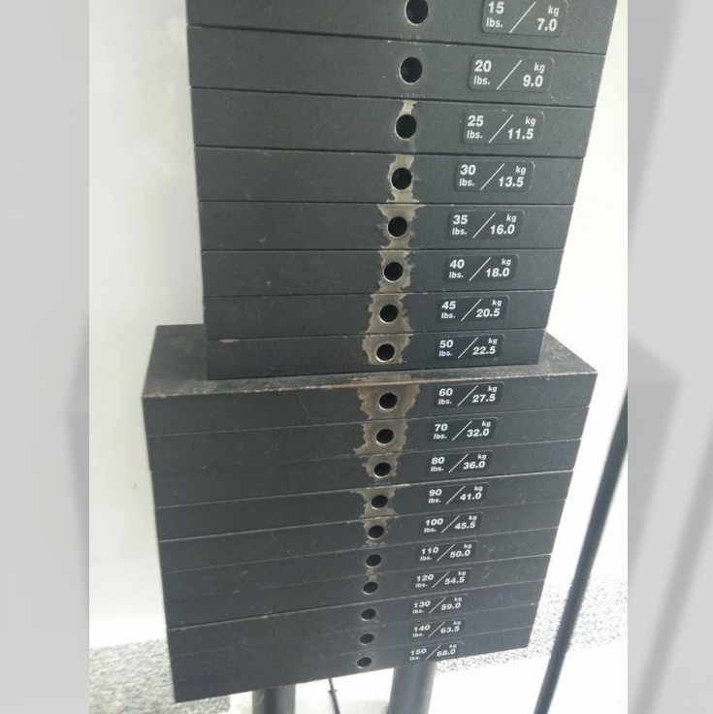

﻿﻿

Want to learn more about analogies?

Read this [article from Growth Tribe](https://growthtribe.io/blog/data-storytelling-the-power-of-analogies) or [this article by HBR](https://hbr.org/2005/04/how-strategists-really-think-tapping-the-power-of-analogy).  
﻿﻿